# Project: Resident Evil

Resident Evil is a system that registers virus spreads across the world. It is a significantly big project, and as such it will have several parts.

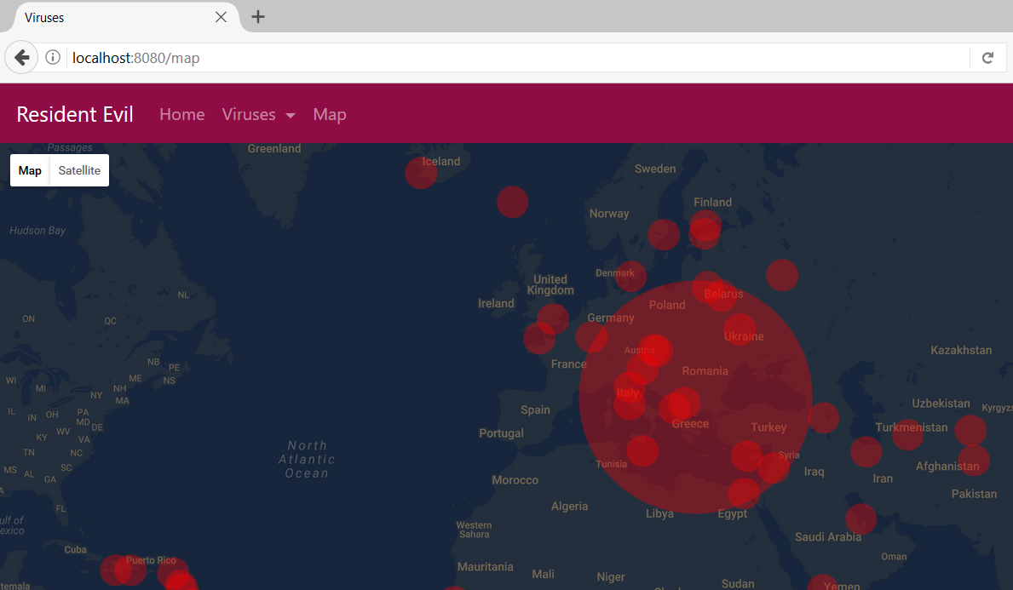

# Exercises: Security

Problems for exercises and homework for the [“Java MVC Frameworks - Spring” course @ SoftUni](https://softuni.bg/trainings/1538/java-mvc-frameworks-spring-march-2017).

The Resident Evil Project is a pretty serious project, as you’ve already heard. As such, it would need to be secured with authentication and authorization measures.

## User Model

Implement a User model, which you will use as the main **Authentication model** in the Resident Evil Project. In future, this User will be changed, but for now let it have the following properties:

* Username
* Password
* Email
* Role – (USER / ADMIN)

Of course, you will need to add the corresponding **Repositories** and **Services**, as the **User** will be **persisted** in the **Database**.

## Roles

There should be three main **roles** in your application:

* ADMIN – should be able to access **everything**.
  + Has all the rights of a **USER**.
  + Has all the rights of a **MODERATOR**.
* USER – should be able to access [/viruses/show], [/home], [/logout].
  + This Role is set by **default**, upon Register.
* MODERATOR – should be able to access [/viruses/add], [/viruses/edit], [/viruses/delete].
  + Has all the rights of a USER.

Anonymous (not **logged-in**) clients should be able to access [/login], [/register], and [/].

Assign the roles from the **database** for now.

## Register Page

Implement a simple Register Page. There will be no example screenshot, as the design does not matter.   
It should hold the following input fields:

* Username
* Password
* Confirm Password
* Email

## Login Page

Implement a simple Login Page. There will be no example screenshot, as the design does not matter.   
It should hold the following input fields:

* Username
* Password

## The Users Controller

Implement a Controller for the Users, which will hold functionalities (Get / Post Mappings) for Login / Register / Logout.

## Custom Authorization

Create a **simple page** (for example on route [/unauthorized] for **access denial**. If, for example, a USER tries to access one of the MODERATOR functionalities, you should **redirect** to **that page**.

## Users Page

Create a page that **lists** **all** the Users. It should be **accessible** **only** for Admins and (only Admins of course) should see it as an element of the navigation bar.

## UI Authorization

Edit the **home view** by using **Thymeleaf Security**. Change the **navigation bar**, adding the following authentication measures.

* If you are **anonymous** you should see:
  + [**Home**] section (**Guest**).
  + [**Register**] section.
  + [**Login**] section.
* If you are **logged in**, but with USER role, you should see:
  + The [**Home**] section (**User**).
  + The [**Viruses**] section (only with [**Show**] action).
  + The [**Logout**] section.
* If you are logged in, but with **MODERATOR** role, you should see:
  + The [**Home**] section (**User**).
  + The [**Viruses**] section (with both [**Show**] and [**Add**] actions).
  + The [**Logout**] section.
* If you are **Admin** you should see **all** sections, including the [**Users**] section.

## Edit User Permissions

The page should **visualize basic data** about the users (for example in a **table**) like Username and Role. The Admins should be able to edit the Role of the Users, making them Users or Moderators or Admins.

You should **NOT be able** to edit your own Role.

## * Secure the Admin Functionality

This task is designed to **secure** the **Admin functionality**, so that the Admins don’t make **critical mistakes**. Such security **should exist** in **every application**. For example, an Admin should **not be able** to delete all other admins.

Implement **only 1** of the 2 choices stated below, as the **2nd choice** will **replace** the **functionality** from the **first**, and **visa versa**.

#### Choice A: Secure the Admins

In the Users section from the **previous task**, **secure** the Admins, by making their Role **unchangeable**.   
This functionality should **trigger instantly**, when a User is made Admin.

**Example**:

* Admin Pesho makes User Gosho – Admin.
* Admin Pesho is no longer capable of editing Admin Gosho’s Role.
* Admin Gosho cannot edit Admin Pesho’s role either.

#### Choice B: Secure the Root

Create a 4th Role, called “ROOT”.

* The ROOT role should have the same permissions as the Admin role.
* The ROOT User’s Role should **NOT** be modifiable by any Admins. Admins can modify everyone else.
* The ROOT User should be able to modify all other Users’s Roles, without exception (even the Admins).
* The ROOT User should be created by:
  + Being seeded with the **initial** **application start-up**
  + Being the **first-registered** User.